**ASSIGNMENT-2**

**Python Programming**

|  |  |
| --- | --- |
| Date | 24 September 2022 |
| Student Name | THIYAGARAJAN M |
| Roll No | 710019106048 |
| Team ID | PNT2022TMID42262 |
| Project Name | PERSONAL ASSISTANCE FOR SENIORS WHO ARE SELF-RELIANT |

**QUESTION 1. Build a python code, assume you get temperature and humidity values (generated with random function to a variable) and write a condition to continuously detect alarm in case of high temperature.**

**Solution:**

import random

temp=random.randint(20,50)

hum=random.randint(50,80)

print ("Temperature:",temp,"°C")

print ("Humidity:",hum,"%")

if(temp>=30):

print ("Temperature is High")

print ("Alarm is ON")

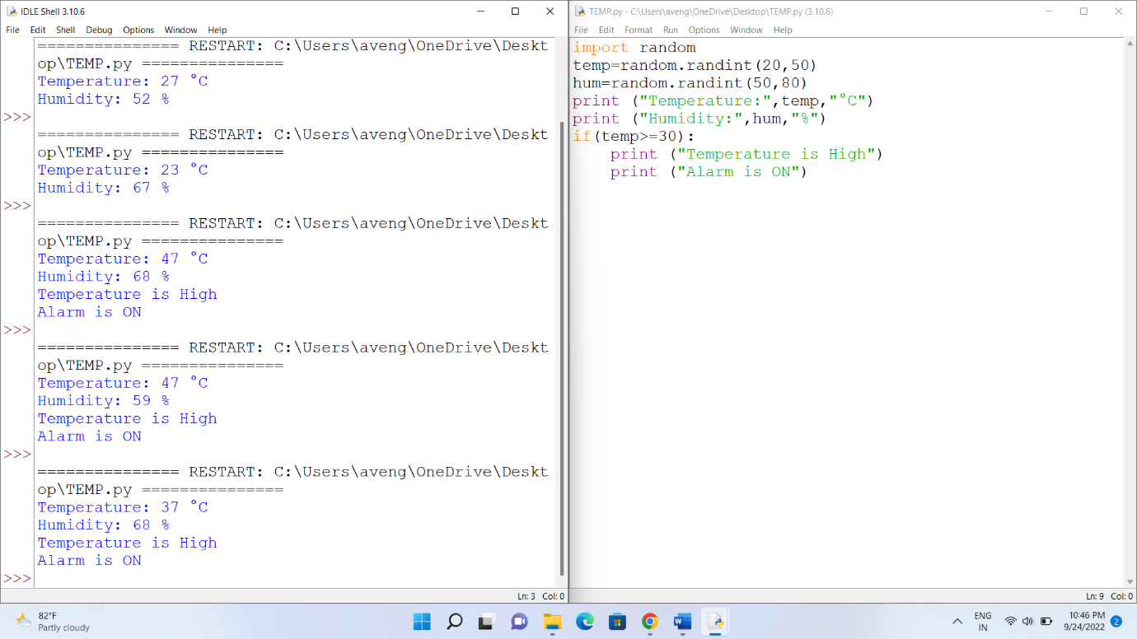

**OUTPUT:**

